2.1 - Labs (5)

* Lab 2.1.5 (1) Essentials of if-else statement [A]

#include<iostream>

using namespace std;

int main()

{

setlocale(LC_ALL,"RUS");

int year;

cout << "Введите год: ";

cin >> year;

if (year % 4)

cout << "Невысокосный год." << endl;

else

cout << "Высокосный год.";

system("pause");

return 0;

}

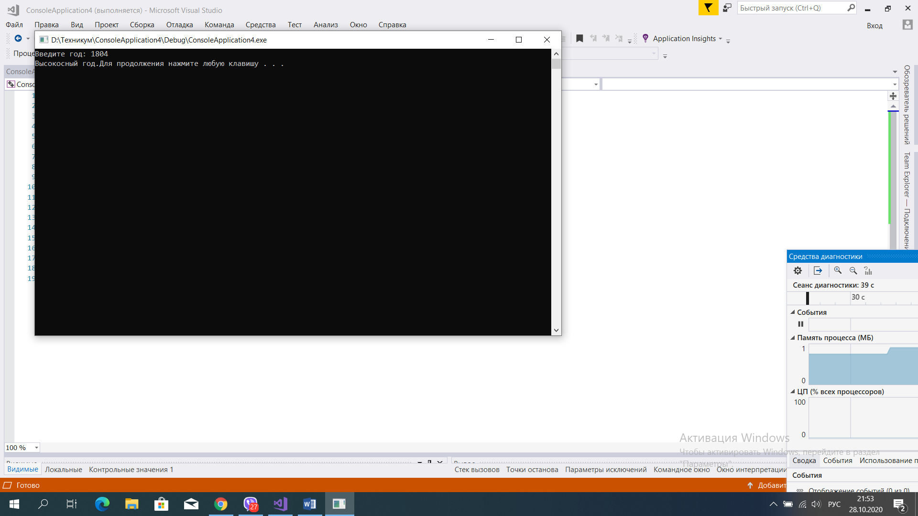

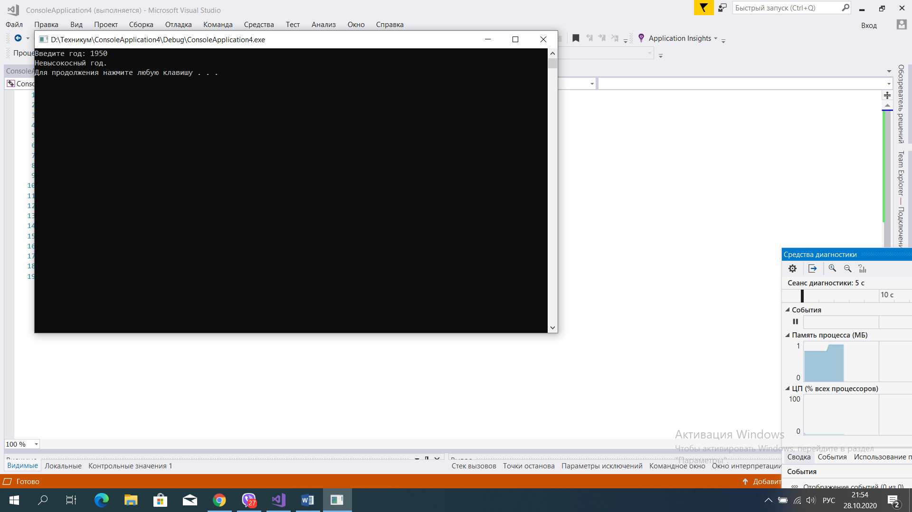

* Lab 2.1.5 (2) Some actual evaluations - taxes [B]

#include<iostream>

using namespace std;

int main()

{

setlocale(LC_ALL,"RUS");

float grossprice, taxrate, netprice, taxvalue;

cout << "Введите валовую цену: ";

cin >> grossprice;

cout << "Введите налоговую ставку: ";

cin >> taxrate;

netprice = (grossprice * 100) / (taxrate + 100);

cout << "Чистая цена - " << netprice << endl;

taxvalue = grossprice - netprice;

cout << "Налоговая стоимость - " << taxvalue << endl;

system("pause");

return 0;

}

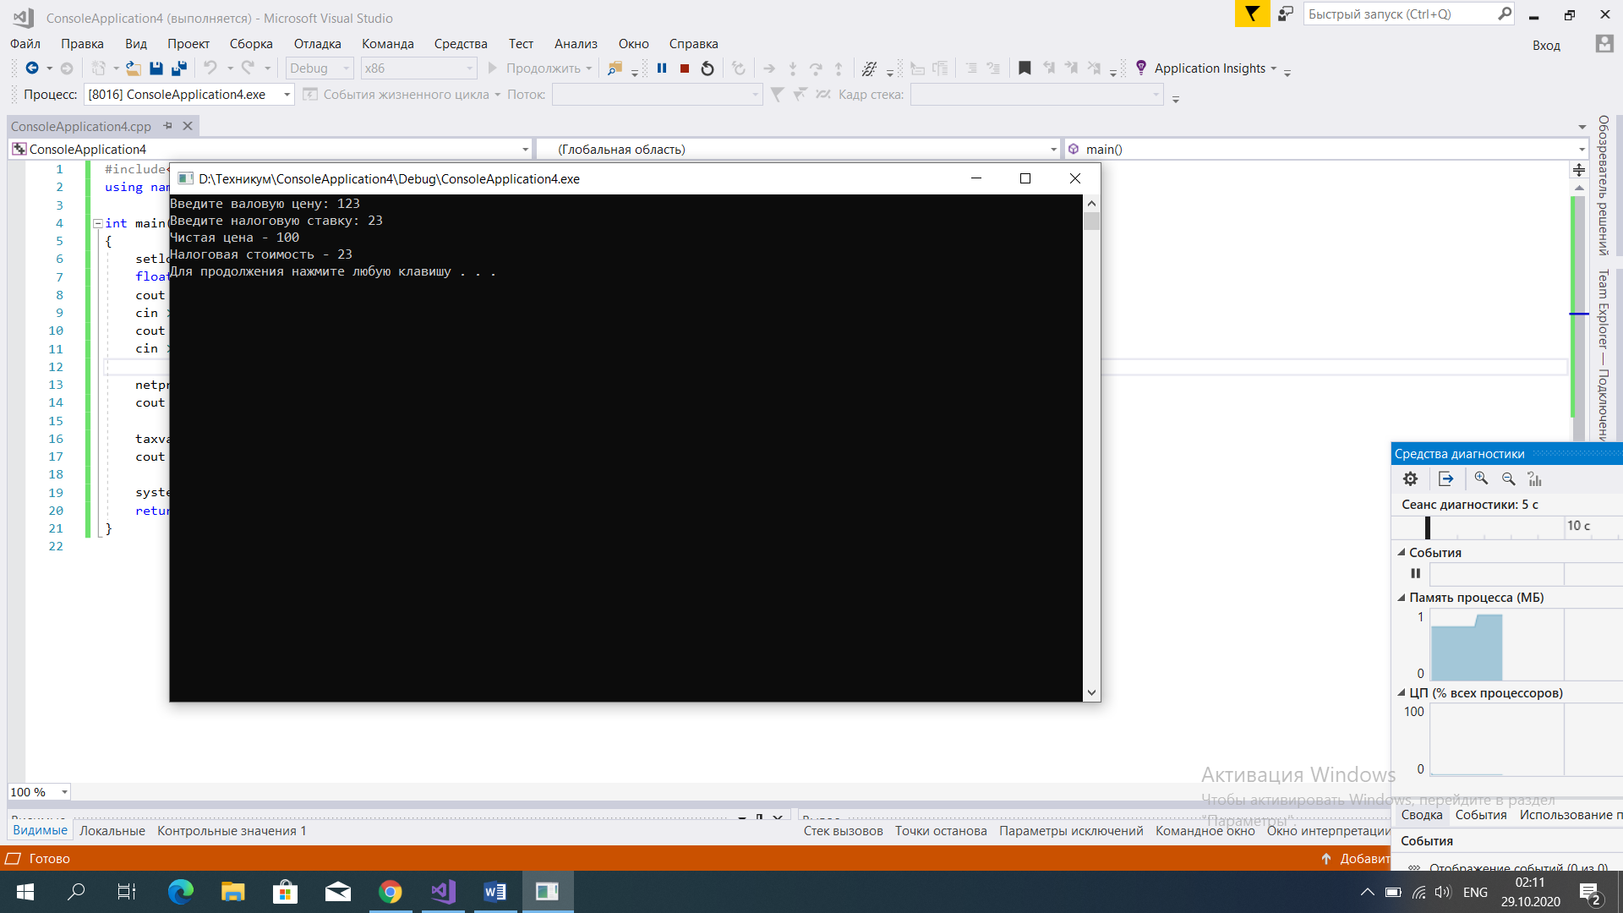

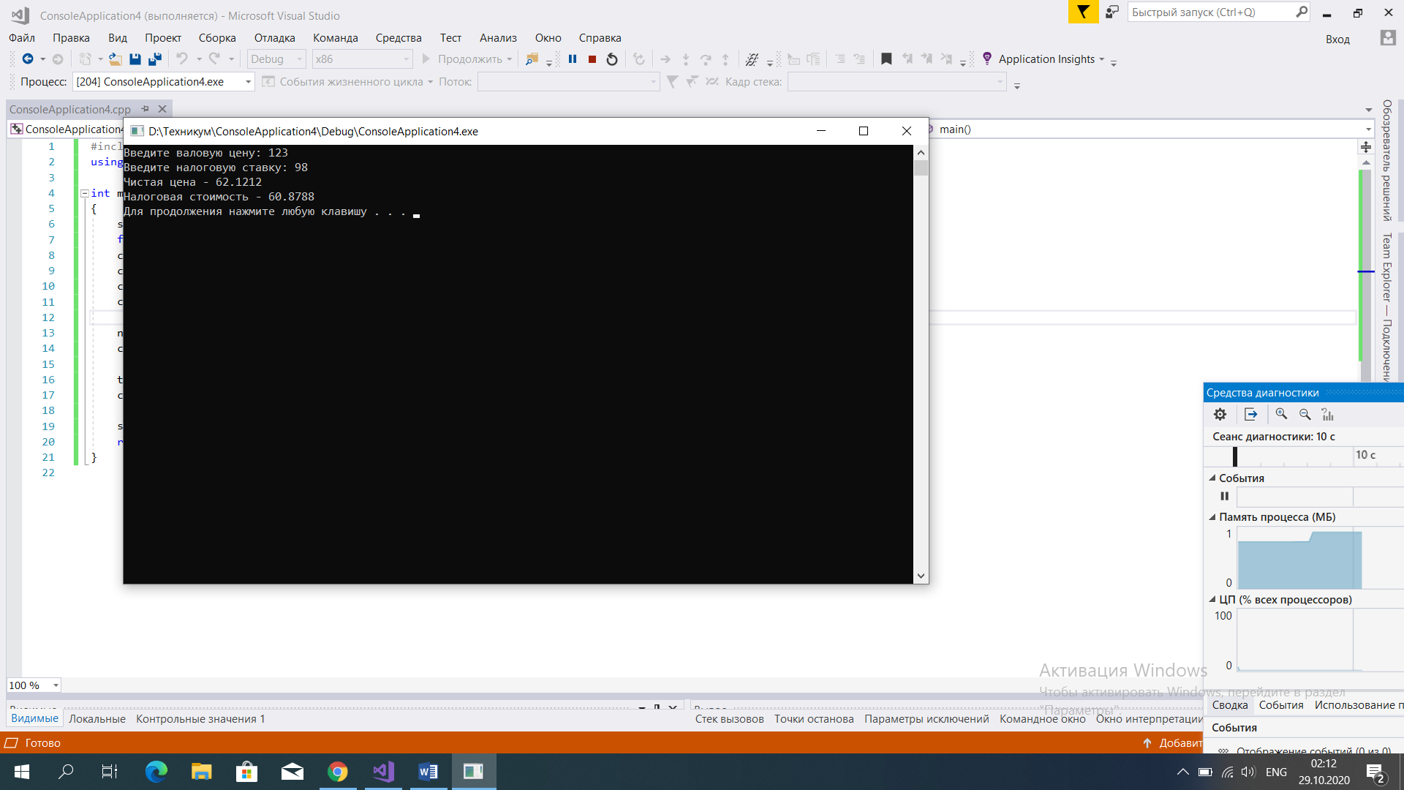

* Lab 2.1.5 (4) Some actual evaluations - finding day of week [B]

int main()

{

setlocale(LC_ALL,"RUS");

int d, m, y, k;

cout << "Введите год: ";

cin >> y;

cout << endl;

cout << "Введите месяц: ";

cin >> m;

cout << endl;

cout << "Введите день: ";

cin >> d;

cout << endl;

m = m - 2;

if (m < 0)

{

m = m + 12;

y = y - 1;

m = (m * 83) / 32;

m = m + d;

m = m + y;

m = m + (y / 4);

m = m - (y / 100);

m = m + (y / 400);

m = m % 7;

}

else

{

m = (m * 83) / 32;

m = m + d;

m = m + y;

m = m + (y / 4);

m = m - (y / 100);

m = m + (y / 400);

m = m % 7;

}

cout << "День недели - " << m << endl;

system("pause");

return 0;

}

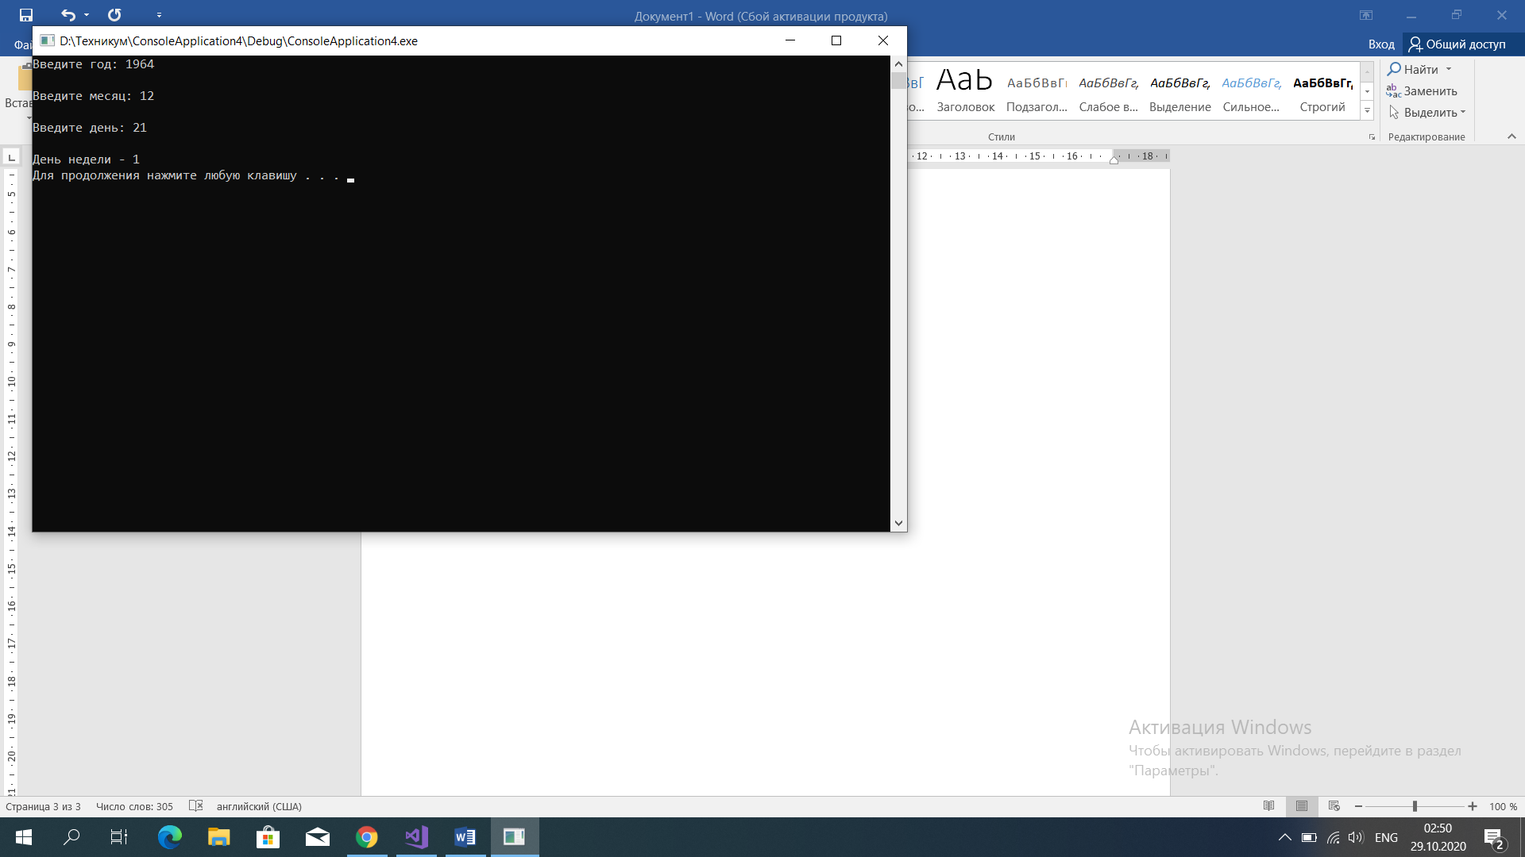

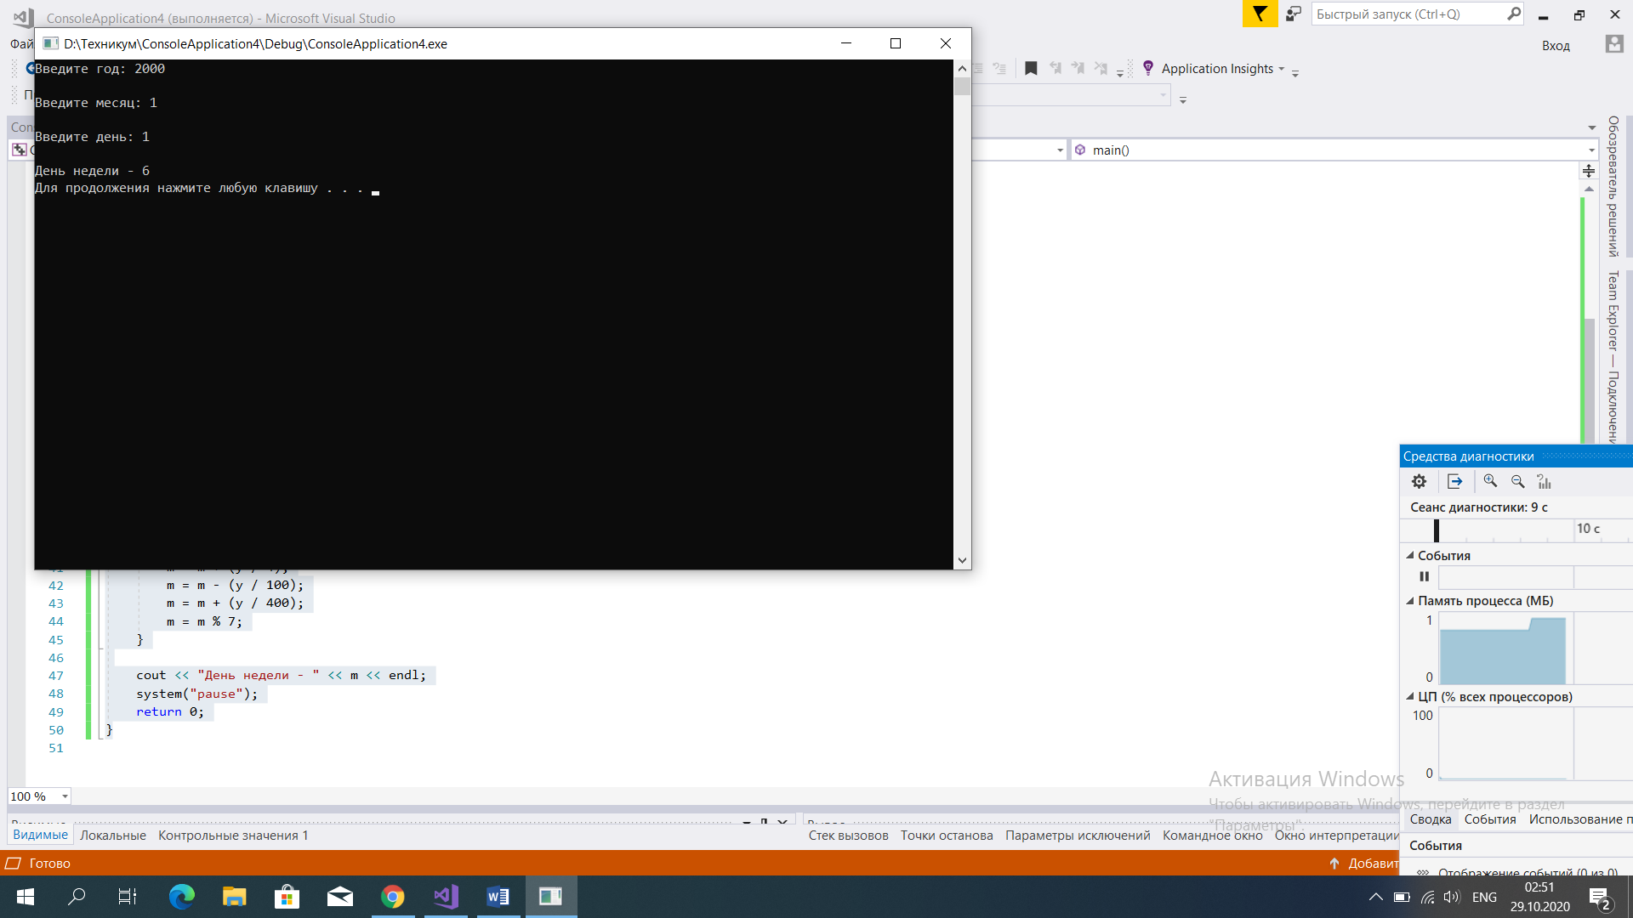

* Lab 2.1.5 (5) Some actual evaluations - finding date of Easter [B]

#include<iostream>

using namespace std;

int main()

{

setlocale(LC_ALL,"RUS");

int y, a, b, c, d, e, p;

cout << "Введите год: ";

cin >> y;

a = y % 19;

b = y % 4;

c = y % 7;

d = (a * 19 + 24) % 30;

e = (2 * b + 4 * c + 6 * d + 5) % 7;

if ((d + e) < 10)

{

p = d + e + 22;

cout << p << " марта!" << endl;

}

else

{

p = d + e - 9;

cout << p << " апреля!" << endl;

}

system("pause");

return 0;

}

